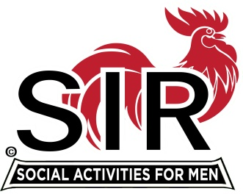
Las Trampas Branch 116
BEC Meeting Agenda
June 20th, 2022, 9:15 AM at Boundary Oaks

The Mission of SIR is to enhance the lives of our members through fun activities, events and luncheons – while making friends for life.

9:15 am Call to order; Secretary, Paul Ramacciotti, confirm a quorum and Approval of Mar 21st 2022 BEC meeting minutes
9:20 Today’s BEC Focus – Fred Wachowicz (Membership, Christmas Party, Lunch Counts, and Membership Confirmation)
9:30 Treasurer - Alan Fitzgerald – Report and any points of risk
9:35 Standing Reports
- Membership – Phil Goff
- RAMP Department Head Reports:
- Recruitment, Don Schroeder
- Activity Coordinator Alex Lutkus standing in for Mike Ward
- Member Relations David Harris (seating plan this month)
- Publicity Al Farbman
- Covid Compliance - Kevin Donahue (Any related updates etc.)

9:45 Old Business

- Lunch Estimate Risks and Options (Mike Schneider)
- Follow-up letter to members (Dues and Membership Confirmation)

9:50 Little SIR Updates – Roger Craig
Speaker Update (Al Farbman and Roger Craig)
Birthday Boys
10:00 Misc. Updates & New Business

- Christmas Party

- Boundary Oaks Branches, Area Branches, and Overlapping Opportunities
  - Publicity
  - Activities, Branch 19
- Surveys: Online and Table Top
- Volunteers Needed: Publicity Assistants, Treasurer, Recruiting Assistants, Speaker Team Member, Member Relations Assistants
- Nomination Process for 2023 Officers

10:15 am Adjourn; For Lunch Preparations

